UNITED  NATIONS |  | EP
 |  | UNEP/GCSS.XI/10/Add.2
 | Governing Council  of the United Nations  Environment Programme | Distr.: General  15 January 2010  Original: English

Eleventh special session of the Governing Council/
Global Ministerial Environment Forum
Bali, Indonesia, 24–26 February 2010
Item 4 of the provisional agenda∗
Emerging policy issues: environment in the multilateral system

Background paper for the ministerial consultations
Discussion paper presented by the Executive Director
Biodiversity and ecosystems
Summary

The present document has been prepared to provide a succinct background briefing for ministers on the topic of theme III of the ministerial consultations to take place at the eleventh special session of the Governing Council/Global Ministerial Environment Forum: “Environment in the multilateral system: biodiversity and ecosystem services”. It is intended to stimulate discussion during the ministerial consultations.

Introduction
- Discussions at the ministerial consultations to be held during the eleventh special session of the United Nations Environment Programme (UNEP) Governing Council/Global Ministerial Environment Forum will focus on the theme of “Environment in the multilateral system”. Under this overarching theme, three interlinked topics of significant importance on the international agenda will be discussed. The third topic will be “Biodiversity and ecosystems”. The world’s environment ministers will have the opportunity:
  - To discuss the progress made towards attaining the 2010 biodiversity targets and other relevant targets, including those for millennium development goal 7, in the light of the declaration of 2010 as the International Year of Biodiversity;
  - To discuss the study “The economics of ecosystems and biodiversity” (referred to as “TEEB”) and its implications for biodiversity;
  - To obtain an update and discuss the progress made on implementing decisions on the science-policy interface in the form of the intergovernmental platform on biodiversity and ecosystem services;
  - To consider the contribution of UNEP to the United Nations Conference on Sustainable Development in 2012, in particular with regard to its focus on the green economy in the context of sustainable development and poverty eradication and implications for biodiversity and ecosystem services.
- The present paper has been drafted in particular to provide background and context for ministers on biodiversity and ecosystem services. Given the close relationship to other issues to be discussed by ministers at the eleventh special session of the Governing Council/Global Ministerial Environment Forum, however, the paper should be read in conjunction with document UNEP/GCSS.XI/10, entitled “International environmental governance and sustainable development” and document UNEP/GCSS.XI/10/Add.1, entitled “Green economy”.
- The present paper addresses the potential for further synergies among the biodiversity-related conventions and recent calls for action to review the biodiversity targets. It maps out the importance of biodiversity and ecosystem services to human well-being and outlines how climate change exacerbates biodiversity loss and ecosystem degradation. It discusses the findings of the TEEB study and stresses the importance of strengthening the science-policy interface within the biodiversity field. The paper also highlights the momentum posed by the celebration of the International Year of Biodiversity for developing new targets and programmes. Lastly, a number of thought-provoking questions are posed to support discussions during the ministerial consultations.
- Background
- International concern for the conservation of biodiversity and habitats has been expressed for decades. In the 1960s, negotiations began on the Convention on Wetlands of International Importance, Especially as Waterfowl Habitat (Ramsar Convention) and the Convention on International Trade in Endangered Species of Wild Fauna and Flora (CITES). In 1971, the adoption of the Ramsar Convention codified international concern at the increasing loss and degradation of wetland habitat for migratory waterbirds. Just two years later, CITES was adopted in an effort to meet concerns about the international trade in biodiversity that threatened the very survival of some wild animals and plants.
- In 1979, greater recognition of the importance of wildlife habitats and the need to conserve migratory species throughout their range led to the adoption of the Convention on the Conservation of Migratory Species of Wild Animals, thereby affirming the need for strict protection of the most endangered species.
- Subsequently, in 1992, the importance of biodiversity was given a further significant boost with the adoption of the Convention on Biological Diversity. The Convention, as an integrative concept, knits together all forms of life – from genes to species to ecosystems – that produce the world’s priceless ecological infrastructure and provide vital services.
- Those four conventions, along with the International Treaty on Plant Genetic Resources for Food and Agriculture and the Convention Concerning the Protection of the World Cultural and Natural Heritage (World Heritage Convention), make up the cluster of global biodiversity conventions.
- Synergies
- Processes such as the Joint Liaison Group and the Biodiversity Liaison Group have been in place for the past several years to find synergies between the biodiversity-related conventions. Their mandates focus on identifying options for joint work programmes. There remains ample scope for making further progress with synergies between the biodiversity-related conventions and countries have, through the General Assembly, the UNEP Governing Council/Global Ministerial Environment Forum and the various conferences of the Parties, expressed interest in further exploring such synergies.
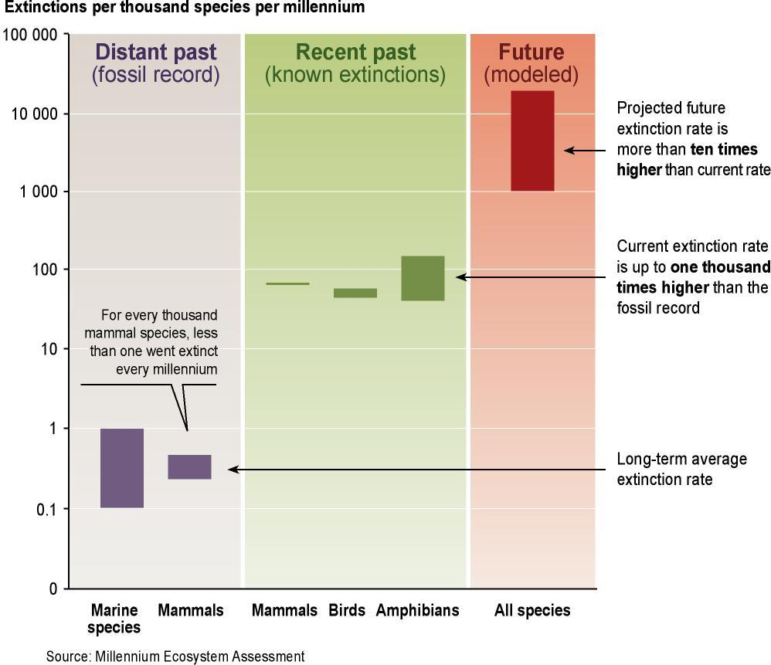
- UNEP will draw on the continuing efforts to build synergies between multilateral environmental agreements within the chemicals and wastes cluster and will focus on achieving synergies between biodiversity-related conventions over the coming biennium in a manner consistent with its mandate, while fully recognizing the authority and autonomy of the various conferences of the Parties. As detailed in several assessments of the need for synergies (including the report of the Joint Inspection Unit on environmental governance and the work of the Environment Management Group on synergies between biodiversity-related multilateral environmental agreements) options to work on synergies between biodiversity-related conventions exist and are issue-based and thematically linked. The new global biodiversity targets currently being discussed also provide a good opportunity to identify further options for greater synergies.
Species extinction rates. Comparisons with the rate at which species have disappeared from the planet over a long period of Earth’s history indicate that humans have already increased extinctions levels dramatically. Projections suggest that this rate will take another big leap due to changes over the next 50 years. The bars represent the range of estimates in each case.
- Work through the Poverty and Environment Initiative, which is jointly administered by the United Nations Development Programme (UNDP) and UNEP, is endeavouring to focus on national plans to implement the Millennium Development Goals. In support of such action, UNEP, in partnership with UNDP, will publish a report on linkages between biodiversity and the goals during the high-level segment on biodiversity of the sixty-fifth session of the General Assembly, in 2010.
- The discussions during that segment, to include the participation of heads of State, are intended to provide the highest level of focus on biodiversity. Agencies and ministries responsible for biodiversity must help to ensure that appropriate messages are brought to the attention of heads of State to assist them in devising specific recommendations on how to move the global biodiversity agenda forward.
- Biodiversity and ecosystem services for human well-being
- The Millennium Ecosystem Assessment was launched in 2001 following a call by the Secretary-General. Its objective was to assess the consequences of ecosystem change for human well-being and the scientific basis for action needed to enhance the conservation and sustainable use of ecosystems and their contribution to human well-being. It involved the work of more than 1,360 experts worldwide, whose findings provided a state-of-the-art scientific appraisal of the condition of and trends in the world’s ecosystems, the services that they provide and the options for restoring, conserving and enhancing the sustainable use of ecosystems.
- The Millennium Ecosystem Assessment sounded a clarion call regarding the fate of the world’s ecosystems and the services that they provide, which are essential to human well-being. In 2005, the Assessment stated that 60 per cent of those services were being severely degraded or used unsustainably, but biodiversity loss continues even now. For example, bird, mammal and amphibian species used by humans for food and medicine are showing declining trends in their conservation status similar to or higher than for species not used for such purposes. The loss of these and other species could affect significantly human well-being in some parts of the world. For example, it has recently been argued that the rapid and widespread die-off of coral reefs costs $172 billion annually and affects over 500 million people whose livelihoods depend on the services that they provide.

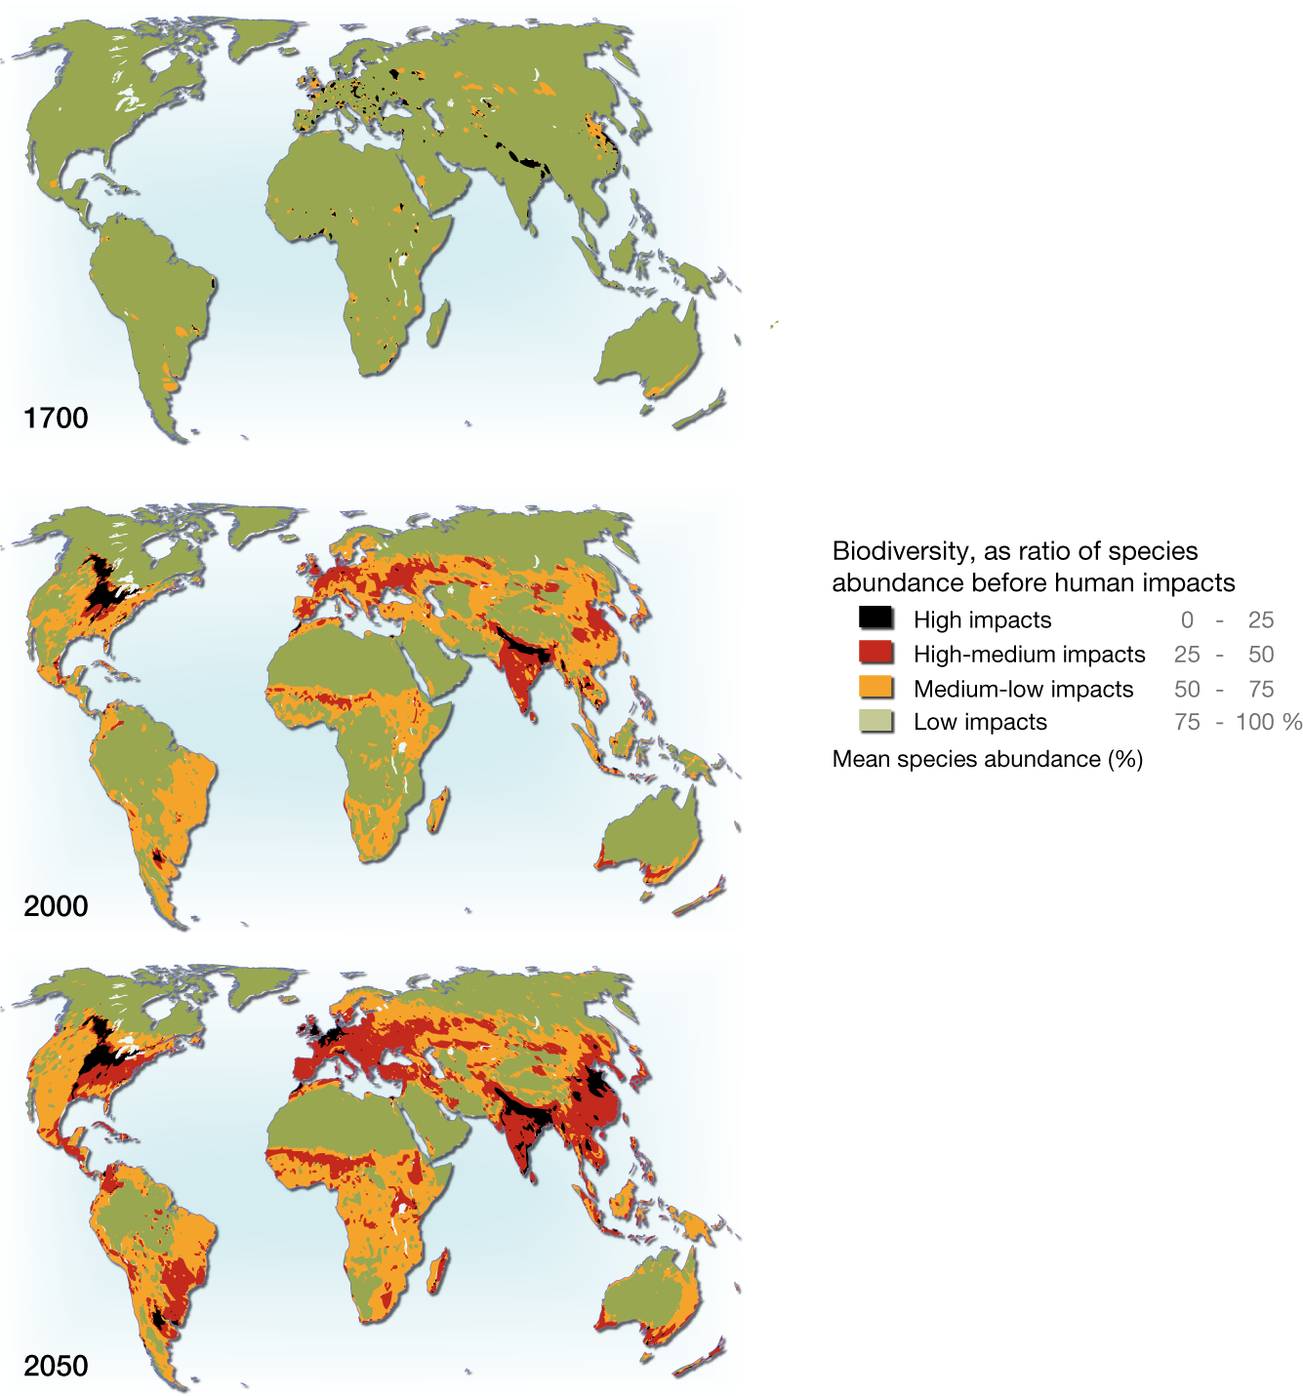

Loss of biodiversity with continued agricultural expansion, pollution, climate change and infrastructure development. Source: GLOBIO; Alkemade and others, 2009.
- The Millennium Ecosystem Assessment and other work have also concluded that growing consumer demand to satisfy global lifestyle choices and consequent patterns of natural resource consumption are incompatible with sustainable development. It therefore comes as no surprise that species loss and ecosystem degradation are being reported worldwide. Such broad-scale ecosystem changes and the drivers of those changes are now widely recognized and better understood. Small-scale and large-scale conversion of land to agriculture for food crops and livestock, logging, infrastructure and commercial development and the rapid expansion of commercial-scale biofuel production have been widespread and are significant drivers of biodiversity loss. Increasingly closely linked is the persistent and unsustainable use of natural commodities, both for commercial and subsistence purposes. Excessive and growing demand for marine and freshwater fish, the meat of wild animals, timber and non-timber forest products, medicines and aromatics – often through unregulated trade – are driving patterns of species loss and widespread habitat transformation.
- Economics of ecosystems and biodiversity (“TEEB”)
- In March 2007, the ministers of environment of the Group of Eight, together with representatives of the five major newly industrializing countries – Brazil, China, India, Mexico and South Africa – convened in Potsdam, Germany. They concluded that there was a need to increase the attention paid to the economics of ecosystems and biodiversity, similar to that accomplished for climate change through the success of The Stern Review. In the light of this challenge, the German Government proposed a study on the economic significance of the global loss of biological diversity. As a result of the agreement reached on the subject by the Group of Eight at its summit in Heiligendamm, Germany, from 6 to 8 June 2007, the German Federal Ministry for the Environment and the European Commission, with the support of several other partners, jointly initiated work on this global study, entitled “The economics of ecosystems and biodiversity” (“TEEB”).
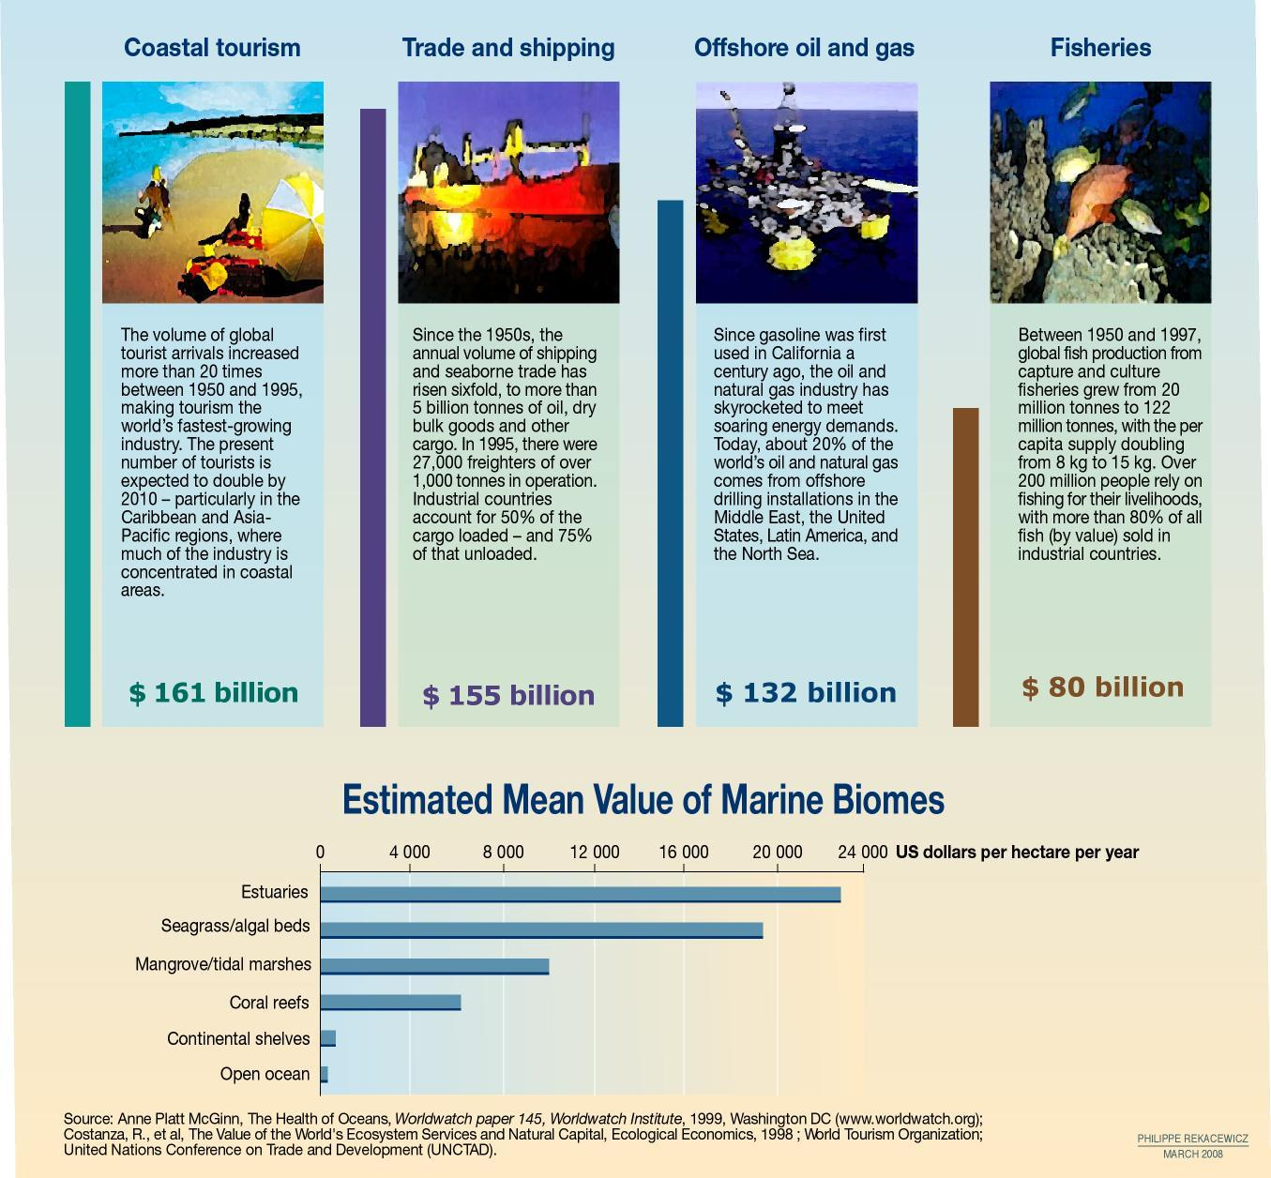
- Three TEEB reports have since been released: TEEB – An Interim Report, in May 2008; TEEB Climate Issues Update, in September 2009; and TEEB – The Economics of Ecosystems and Biodiversity for National and International Policy Makers, in November 2009. Overall, the study aims to draw together experience, knowledge and expertise from all regions in the fields of science, economics and policy to enable practical actions to be taken in response to the growing evidence of the impact of biodiversity loss. The study seeks to show that economics acts as a powerful instrument in policymaking for biodiversity and ecosystems through supporting decision-making processes and facilitating dialogue that takes into account science, economics and governing structures.
- As set out in the study, the loss of ecosystem services directly affects economic development, yet the value of these same services is continually underestimated. The loss of soils, forests, fisheries, coral reefs and wetlands is increasing at alarming rates. It should be noted, however, that just as natural capital declines so too does sustainability. The lack of understanding of the economic (i.e., monetized) value of ecosystem services is a key factor in the fact that most people do not look beyond the present day. Until these services are better valued and recognized, many cost-effective, win-win solutions will not be recognized.
- The recent report aimed at policymakers outlines some critical areas to be tackled to value natural capital better, including the promotion of better tools to measure benefits and improve ability to distribute both costs and benefits.
- First and foremost, the study makes the point that management requires measurement. There must be enhanced understanding and quantitative measurement of biodiversity and ecosystem services if national and international decision-making processes towards a long-term solution are to be supported. It is also important to develop both hard and soft tools that will support and promote better stewardship and equity, including a more robust system of payment for ecosystem services (for example, through market mechanisms). There is a need to revisit harmful subsidies and instead work through regulatory frameworks and environmental standards to minimize and reverse the loss of biodiversity.

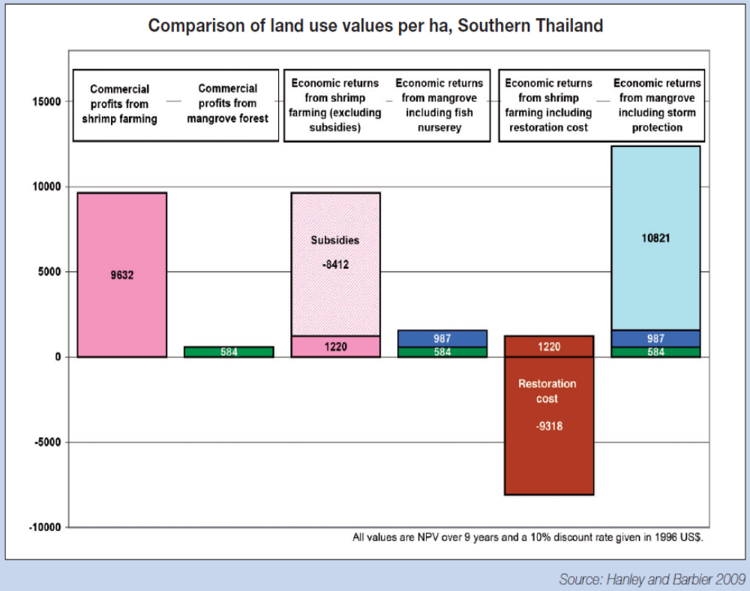

- Though not yet complete, the move to a low-carbon society has received significant attention and is increasingly a key factor in national and international decision-making on everything from urban development to forestry and agriculture. As TEEB for Policy Makers points out, it is crucial to build on this success and move such decision-making towards greater resource efficiency overall. For biodiversity and ecosystem services, the study argues that the points raised above must be achieved for their values and benefits to be taken into account in the same way as carbon is now recognized.
- The “Carta di Siracusa” concluded in April 2009 (see the annex to the present paper) not only reaffirmed a commitment to biodiversity and ecosystems, but specifically referenced the study and the importance of the private sector, civil society and individual citizens becoming involved in its development.
- Industry has an enormous role to play in changing how natural capital is viewed. The very survival of some industries, irrespective of size, is linked to healthy ecosystems. They must help to redress the failure of market forces to ensure the sustainability of the global economy and meet the pressing need to liberate billions of people from the poverty trap that has been constructed, lest the very services upon which the world depends become no longer cost-effective or even available. Another report in the series, TEEB for business, is to be published in 2010. It will identify opportunities to work with and through industry to deliver a more resource-efficient economy.
- In short, the world faces significant risks if the issues of biodiversity loss and ecosystem service degradation are not tackled and if there is no recognition of the value of what is being lost. There is a need to change tack regarding this valuable natural capital. It will require tremendous effort and international cooperation, but the existing evidence shows that it will undoubtedly be worthwhile.
- Powerful linkages and synergies are likely also to be enhanced by closer engagement of Governments and civil society with the private sector. This will be needed to drive the changes required to build a genuine green economy. The scheduled outputs of studies and the growing energies behind new entrepreneurial initiatives present clear opportunities to bolster these important relationships.

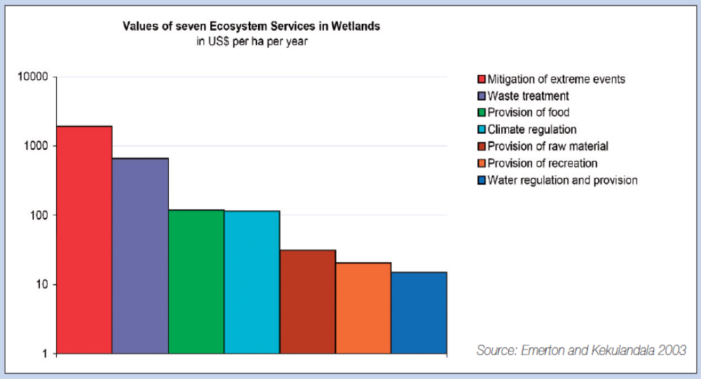
- Climate change, biodiversity and ecosystem services
- Changes in the global climate and biodiversity are closely linked. While climate change is a significant driver of biodiversity loss, healthy biodiversity and resilient ecosystems provide a natural means to adapt to climate change.

With a temperature increase of only 1.5°–2.5°C, more than 30 per cent of all species globally will be threatened with extinction.

Fourth assessment report, IPCC, 2007
- The Intergovernmental Panel on Climate Change in its fourth assessment report, released in 2007, made several groundbreaking findings. It estimated significant losses in global biodiversity, with regional impacts even higher. Many ecosystem services were also projected to be lost, including disease and storm regulation; water availability and hydropower potential; food production and tourism.
- The Panel also indicated that climate change would exacerbate other drivers of biodiversity loss and ecosystem degradation. Habitat destruction would therefore increase, in particular in coastal areas, as a result of sea-level rise and storm surge. The number of invasive species was also expected to increase as a result of higher temperatures.
- Other studies estimate that over the coming 40 years climate change impacts could result in species turnover of up to 60 per cent at the global level as a result of significant species extinctions in subpolar and tropical ecosystems and semi-enclosed seas alongside unprecedented species invasions in the arctic and southern oceans. Specifically, mass coral bleaching events, which apparently began as atmospheric carbon dioxide exceeded 320 ppm, are escalating as levels approach 390 ppm. Coral reefs will likely become home to algae and other micro-organisms with a greatly reduced capacity to support higher life forms.
- In terrestrial systems climate-forced distribution shifts will also probably lead to species losses, as those in low-lying areas are affected by rising sea levels and subsequent salt-water intrusion and others experiencing altitudinal shifts simply run out of room to move. Physical changes to systems will help to drive additional changes, including significant shifts in the timing of important processes such as flowering and pollination, reproductive timing, seasonal migrations and changes in the structure of biological communities.,
- The concept of reducing emissions from deforestation and forest degradation (REDD) is swiftly developing and could save the world’s forests and maintain their ability to regulate carbon. In addition to the mitigating effects of REDD, what is known as “REDD-plus” takes the mechanism one step further and looks at some other aspects, including the sustainable management of forests and enhancing forest cover. The concept will therefore improve livelihoods, biodiversity conservation and ecosystem resilience.
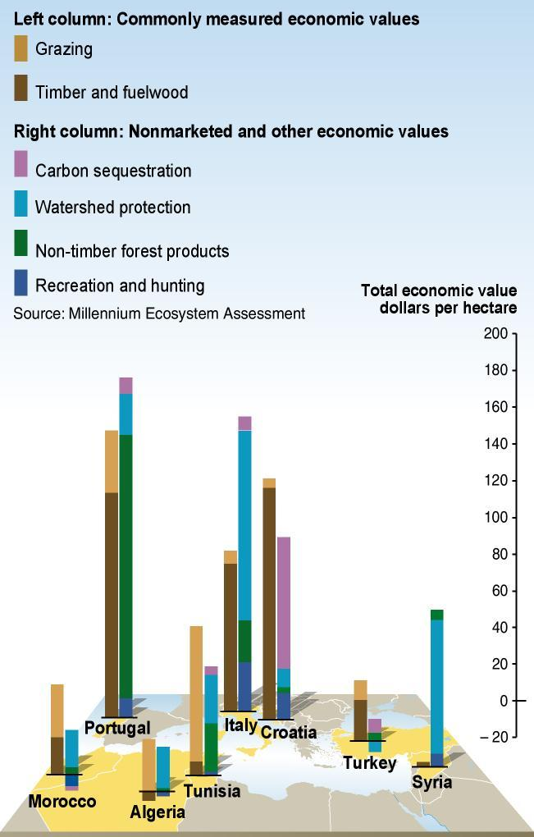
- This and ecosystem-based adaptation approaches would support the building of essential linkages and greater synergies between the needs to safeguard biodiversity and to mitigate and adapt to the impacts of climate change. Such efforts will include steps to meet the need to provide functional approaches to improving the flow of resources to those people whose lives are most closely affected by both climate change and biodiversity loss and whose futures stand to be most significantly improved through such efforts.
Annual flow of benefits from forests in selected countries. In most countries, the marketed values of ecosystems associated with timber and fuelwood production are less than one third of the total economic value, including non-marketed values such as carbon sequestration, watershed protection and recreation.
Source: Millennium Ecosystem Assessment
- Science-policy interface on biodiversity and ecosystem services
- By its decision IX/15, the Conference of the Parties to the Convention on Biological Diversity welcomed the agreement of the Executive Director of UNEP to convene an ad hoc open-ended intergovernmental multi-stakeholder meeting to consider establishing an efficient science-policy interface on biodiversity, ecosystem services and human well-being. Through this decision, the Parties recognized the need to improve the ways in which science on biodiversity and ecosystem services was used to inform policymaking.
- Basic research on biodiversity and ecosystems and the collection and analysis of monitoring data by the scientific and management communities, working at all levels and scales, constitute the first step and must be strengthened. The process of informing policy with good science, however, currently falls short of its potential to pass on this crucial information in a clear and understandable manner to those making policy and legal decisions aimed at conserving biodiversity and maximizing the delivery of ecosystem services.
- Awareness of biodiversity as a multifaceted issue requiring scientific knowledge on the links between biodiversity, ecosystem services and human well-being has increased significantly since the completion of the Millennium Ecosystem Assessment. Consultations aimed at establishing an international mechanism for scientific expertise on biodiversity and the global strategy on a Millennium Ecosystem Assessment follow-up both reflect a general agreement on the need to strengthen the science-policy interface in respect of biodiversity and ecosystem services.
- Consequently, the first ad hoc intergovernmental and multi-stakeholder meeting on an intergovernmental science-policy platform on biodiversity and ecosystem services was held in Putrajaya, Malaysia, from 10 to 12 November 2008. Representatives at the meeting generally agreed that there was a need to strengthen the science-policy interface and to undertake a gap analysis, and recommended that the UNEP Executive Director should seek guidance from the UNEP Governing Council regarding a process for finding the best option to strengthen the science-policy interface.
- By its decision 25/10, the Governing Council called for UNEP to undertake a further process to explore ways and means to strengthen the science-policy interface. In response, UNEP invited Governments and organizations to participate in an open peer review of a preliminary gap analysis on existing interfaces on biodiversity and ecosystem services developed in response to the Putrajaya meeting.
- In October 2009, UNEP convened a second such meeting, the documents for which included a gap analysis in which the institutional landscape on the science-policy interface on biodiversity and ecosystem services was reviewed and various findings presented. A companion document on needs and actions, which outlined existing opportunities and how to take advantage of them, was made available to take the findings one step further. The meeting Chair produced a summary of the meeting, in which he proposed potential functions of a new platform and set out ideas on a governance structure and the way forward. The Chair also said that, in general, there was strong support for a new intergovernmental mechanism to strengthen the science-policy interface on biodiversity and ecosystem services and noted that such a mechanism should provide credible, legitimate and relevant scientific information on biodiversity and ecosystem services that was policy-relevant but not policy-prescriptive. Most meeting participants endorsed the importance of ensuring the scientific independence of a new intergovernmental mechanism by having its governance structure separate from, but supportive of and complementary to, the governance structures and subsidiary bodies of relevant multilateral environmental agreements and United Nations bodies.
- In his summary the Chair also identified the need to strengthen the generation of knowledge at the national, regional and global levels and the general agreement on the importance of capacity-building for the generation, assessment and use of knowledge at various levels. Capacity-building for scientists, policymakers and members of civil society, including local communities, should be catalysed to enable them to participate more effectively in the science-policy interface and to increase the participation of scientists from developing countries.
- At its eleventh special session, the Governing Council will be requested to decide on an approach to further and deepen these discussions on the design of a meaningful and viable mechanism to serve the needs of national Governments and the international community in filling the many gaps found in the course of the various analyses undertaken.
- International Year of Biodiversity

The failure to protect biodiversity should be a wake-up call. Business as usual is not an option. We need a new biodiversity vision. We must manage our forests sustainably so they can store carbon, protect watersheds and provide resources and income. We must conserve coral reefs so they can continue to protect coasts from storms and support livelihoods for hundreds of millions of people. We must ensure the long-term viability of our seas and oceans.
Secretary-General
9 November 2009
- As the International Year of Biodiversity, 2010 will be a year of events targeted at raising global awareness of the role of biodiversity within the context of ecosystem functioning and service delivery. This is a unique opportunity for all relevant stakeholders not only to raise awareness of the role and relevance of biodiversity in securing human livelihoods and well-being, but also to portray it as a viable, long-term, sustainable option to boost countries’ economic well-being.
- It is generally agreed that the target to reduce the rate of biodiversity loss by 2010 has not been met. In the latest reports submitted by the Parties to the Convention on Biological Diversity, many Governments admit that the target will be missed at the national level. Globally, a suite of indicators covering threats, status and response used by the Convention on Biological Diversity supports this conclusion. While efforts to reduce deforestation and increase levels of biodiversity protection have achieved some success, overall biodiversity is still declining and species are increasingly threatened. Nearly 17,000 plant and animal species are known to be threatened with extinction. Major threats and drivers of biodiversity loss, such as over-consumption, habitat loss, invasive species, pollution and climate change, are not yet being effectively tackled.
- Nonetheless, efforts have begun to develop a new set of goals and targets to halt biodiversity loss based on the lessons learned during the current phase of implementing actions. UNEP and others are working to identify new global biodiversity goals and targets and ensure that they are not only responsive to emerging challenges but are also simple, measurable and understood by all relevant sectors, such that a common agenda for action can be developed.
- Discussions are under way in various forums, including through the Environment Management Group, to identify the inputs required to design a new global vision for biodiversity conservation action. These inputs will be developed in preparation for the high-level segment on biodiversity during the sixty-fifth session of the General Assembly, in September 2010, and the tenth meeting of the Conference of the Parties to the Convention on Biological Diversity, in October 2010.
- The International Year of Biodiversity presents an important opportunity for global agreement on an ambitious and meaningful set of post-2010 goals and targets. It will provide impetus to States to redouble their efforts to conserve biodiversity. It will be crucial for baselines and well-articulated targets to be clearly defined using agreed metrics. An agreed suite of indicators will then enable the monitoring of progress and the early adjustment of key policies and actions based on assessment of achievements along the way. This work could be greatly assisted through improved access to and sharing of existing biodiversity-relevant data and information, making it more readily and openly available to a wider community of users, including policymakers.
- Recent calls for action
- The number of contracting parties to the various multilateral environmental agreements has risen over the past 30 years, as countries have increasingly committed themselves to a variety of actions to conserve biodiversity. More than three decades of international and national recognition of the importance of biodiversity notwithstanding, there remains a struggle to protect adequately the very essence of life.
- Ten years after the adoption of the Convention on Biological Diversity, during the World Summit on Sustainable Development in 2002, heads of State recognized the role of biodiversity in sustainable development and poverty eradication, together with its importance for human well-being and for human livelihood and cultural integrity.
2010 biodiversity target

“To achieve by 2010 a significant reduction of the current rate of biodiversity loss at the global, regional and national level as a contribution to poverty alleviation and to the benefit of all life on earth.”

Convention on Biological Diversity decision VI/26
- More recently, multiple organizations and forums have taken up the call to achieve the 2010 biodiversity target (see text box, right, and the annex) and to improve the conservation of biodiversity and ecosystem services.
- The United Nations has designated 2010 the International Year of Biodiversity, thus bringing the subject into greater focus. This is merited, since biodiversity has arguably received inadequate attention relative to its recognized role in human well-being, sustainable development and poverty eradication.
- In October 2010, the Conference of the Parties to the Convention on Biological Diversity will convene its tenth meeting, in Nagoya, Japan. The Parties will review the 2010 biodiversity target and are expected to adopt a new strategic plan with a post-2010 biodiversity target and framework, in addition to considering the international regime on access and benefit-sharing with regard to genetic resources.
- Discussions on the finalization of the access and benefit-sharing regime are under way, with the final negotiating meeting to take place in March 2010 in Cali, Colombia. The nature of and issues pertaining to benefit-sharing, the roles and responsibilities of provider and user countries and compliance elements remain under discussion. The outcomes of this discussion will be transmitted to the Conference of the Parties at its tenth meeting and will form a significant part of the agenda.
- Momentum has been building for decades to improve the understanding, conservation and sustainable use of biodiversity and ecosystems, though more remains to be done. What is now needed is not another strategy for action, but a fundamental change in the approach to reducing and subsequently halting biodiversity loss while maximizing the delivery of ecosystem services.
- If biodiversity loss and ecosystem degradation are to stop, action should be directed at containing the negative impacts of their drivers, something that goes beyond the scope of the environment. This will require collective action at the highest political level to conserve and use biodiversity sustainably while reducing the pressures on ecosystems.
- President’s summary: some possible messages
- The Governing Council/Global Ministerial Environment Forum is the United Nations high-level environmental policy forum and brings the world’s environment ministers together to review important and emerging policy issues in the field of the environment. The Council/Forum provides broad policy advice and guidance with the aim, among others, of promoting international cooperation in the field of environment. In so doing, it invites officials of United Nations agencies and heads of multilateral environmental agreement secretariats to participate and interact with ministers at meetings and seeks to promote the meaningful participation of representatives of major groups and non-governmental organizations, including the private sector.
- It has become the practice for the President of the Council/Forum to prepare a summary of the ministerial consultations that take place at each session. The summary provides an opportunity for environment ministers collectively to send a message to the United Nations system, Governments, civil society and the private sector on their perspective on the topics under discussion.
- In addition to the summary, the President has proposed that the Council/Forum should also adopt a ministerial declaration, statement or communiqué. A draft has been jointly proposed by the Governments of Indonesia and Serbia.
- While it is entirely a matter for ministers to decide, a number of questions are suggested to help to stimulate the ministerial discussions:
- Does the United Nations Conference on Sustainable Development to be held in Rio de Janeiro, Brazil, in 2012 provide an opportunity for Governments to agree on the specific steps and policies required to achieve a green economic future, in a manner that brings about change to how natural capital is viewed?
- How can we facilitate agreements that include:
- An ambitious but meaningful goal to halt biodiversity loss that will be supported by a set of targets and indicators for the post-2010 era?
- Making biodiversity a business for all and not through a specific convention or ministry?
- Components on access and benefit-sharing?
- Clear opportunities for the voices and experiences of stakeholders to be heard and considered in key decision-making processes?
- Appropriate opportunities to enhance funding, capacities and awareness throughout society to attain the collective goal of a world that is equitable, responsive and progressive?
- How can we best take advantage of emerging mechanisms (e.g., REDD-plus) to promote ecosystem resilience through conserving biodiversity? What other mechanisms exist that have such multiple benefits?
- What steps need to be put in place and what support is necessary to fund conservation efforts while local entities, countries, the private sector and the international community transition to greater use of payment for ecosystem services – which could consequently fund conservation efforts?
- How do we further support the science-policy interface to address the gaps and needs identified through the current intergovernmental process and how best do we conclude the negotiations?
- How do we help build momentum for the Secretary-General’s high-level meeting on 20 September 2010 in New York and the meeting of the Conference of Parties to the Convention on Biological Diversity in October 2010 in Nagoya?

Annex
Forthcoming events related to biodiversity and ecosystem services
- In May 2008, the Group of Eight adopted the Kobe Call for Action for Biodiversity, thereby committing itself to a groundbreaking plan of action to curb biodiversity loss. The plan included the following five key ideas:
- Achieving the 2010 biodiversity target;
- Enhancing the sustainable use of biodiversity;
- Strengthening the designation and management of protected areas;
- Promoting private sector engagement;
- Strengthening scientific capabilities for monitoring biodiversity.
- In May 2008, the Conference of the Parties to the Convention on Biological Diversity at its ninth meeting, held in Bonn, Germany, adopted a range of new decisions pertaining to agricultural biodiversity, biofuels, invasive alien species, forest biodiversity, the ecosystem approach and progress towards the 2010 biodiversity target.
- By its resolution X.1, the Conference of the Parties to the Ramsar Convention at its tenth meeting, held in Changwon, Republic of Korea, in November 2008, adopted a new strategic plan for 2009–2015. The plan will contribute to progress at all levels in the conservation and wise use of wetlands and produce benefits for both biodiversity and human well-being.
- In April 2009, the environment ministers of the Group of Eight met in Syracuse, Italy, and decided on a series of actions on biodiversity in an outcome document known as the “Carta di Siracusa”. The document recalled the earlier Group of Eight dialogues in Potsdam, Germany, in 2007 and Kobe, Japan, in 2008. Recognizing the importance of the 2010 target and the International Year of Biodiversity, the ministers committed themselves to investing in biodiversity as a way out of the economic crisis and decided on a series of actions on biodiversity including links to climate; economics and business; biodiversity and ecosystem services; and scientific research and policy (including a commitment to further the process on a science-policy platform). They also agreed on a common path towards the post-2010 framework on biodiversity.
- In May 2009, ministers of environment attending the World Oceans Conference in Manado, Indonesia, expressed concern in the Manado Ocean Declaration about the continuing loss of marine biodiversity and ecosystems and committed themselves to the long-term conservation of marine living resources and coastal ecosystems through sustainable use.
- Processes related to biodiversity funding currently under way include the fifth replenishment of the Global Environment Facility, which is to take place in early 2010. Several preparatory meetings have been held, but the outcome is yet to be seen.

_________________

 UNEP/GCSS.XI/1.
Also of note, 2011 has been declared the International Year of Forests.
http://www.unep.org/greeneconomy/
In August 2001, a joint liaison group between the Convention on Biological Diversity, the United Nations Framework Convention on Climate Change and the United Nations Convention to Combat Desertification in those Countries Experiencing Serious Drought and/or Desertification, Particularly in Africa (the Rio conventions) was established as an informal forum for exchanging information, exploring opportunities for synergistic activities and increasing coordination. The group comprises the officers of the conventions’ scientific subsidiary bodies, the executive secretaries and members of the secretariats.
To enhance cooperation, a biodiversity liaison group comprising the executive heads of the six biodiversity-related conventions (the Convention on Biological Diversity, the Convention on International Trade in Endangered Species of Wild Fauna and Flora, the Convention on the Conservation of Migratory Species of Wild Animals, the International Treaty on Plant Genetic Resources for Food and Agriculture, the Convention on Wetlands of International Importance, Especially as Waterfowl Habitat, and the Convention Concerning the Protection of the World Cultural and Natural Heritage) was established in 2002 by decision VII/26 of the Conference of the Parties to the Convention on Biological Diversity.
JIU/REP/2008/3.
Martinez, M.L., and others, 2007. “The coasts of our world: ecological, economic and social importance”. Ecological Economics, vol. 63, pp. 254–272.
Nicholas Stern, The Economics of Climate Change: The Stern Review, (Cambridge University Press, 2007).
“Projecting global marine biodiversity impacts under climate change scenarios”. Fish and Fisheries vol. 10, issue 3, pp. 235–251, 2009.
“Predicting global habitat suitability for stony coral on seamounts”. Journal of Biogeography vol. 36, No. 6, pp. 1111–1128, 2009.
“Attributing physical and biological impacts to anthropogenic climate change”. Nature vol. 453, issue No. 7193, pp. 353–357, 2008.
An updated assessment of the risks from climate change based on research published since the fourth assessment report by the Intergovernmental Panel on Climate Change. Published online in Climatic Change, 18 August 2009.
UNEP/IPBES/2/4/Rev.1.
Walpole et al. (2009) Science, vol. 325, pp. 1503–1504.
IUCN (2009) Wildlife in a Changing World: A report based on the analysis of the 44,838 species on the IUCN Red List.

